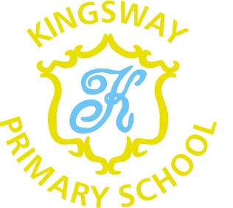

Dear Parents,
Thank you for your continued support and all your hard work keeping up with your child’s home schooling over the last few weeks. We know it is not always easy and we would be happy to help in any way we can. If you have any questions or need help please contact your child’s class teacher via DoJo.
As you may have heard in the press, all schools will close during our half term break from Friday 12th February and key worker and vulnerable pupils will return to their bubbles on Monday 22nd February.
We hope we will hear more information about when and how we are all going to move back to full classes soon. We will let you know details of this as soon as we hear.
Just to keep you in the loop, building works have begun in school to extend the toilet block and provide a disabled toilet and first aid area. This is due to be completed over the next 10 weeks. We are also having a Mental Health Hub built within the school to support pupils as we all recover from the pandemic. This is due to start on Monday 8th Feb. We have also moved back to the provision of cooked meals which will no doubt be welcomed when you return.
Staff continue to work hard taking groups in school, making paper packs and providing on line learning to support all children. They are keen to get back to some normality as soon a it is safe to do so but they are delighted they are now able to communicate with all parents via Dojo. If you have any problems with this communications system then give us a ring at school and we will do our best to help you.
Until we all return best wishes and stay safe.
Yours

Coleen Hibbard
Interim Headteacher

